Guide to
Inpatient Care at
Smokey Point Behavioral Hospital
Information for Patients, Families, and Friends

Hello and welcome to Smokey Point Behavioral Hospital,
Each member of our team strives to achieve our mission of providing a supportive, compassionate, and innovative environment of patient-centered care. You are the most essential member of our team and it is our goal to help you on your way toward recovery and well-being.
We will work collaboratively with you and your care team to develop and implement an individualized treatment plan that provides you with the necessary support and tools to help you better understand and manage your illness and symptoms, strengthen your resilience, and improve your mental health moving forward.
We prepared this handbook as an overview of what you can expect when you arrive at Smokey Point Behavioral Hospital and to address questions and concerns that you and your family may have. We hope that you find this information helpful.
As your community provider for mental wellness, we thank you for trusting Smokey Point Behavioral Hospital.

Contents
How long does the admission process take? 4
What do I need to know once I arrive at the inpatient unit? 5
How long can I expect to stay in the hospital?
Is financial assistance available? 4
Why do different SPBH staff ask me the same questions? 5
What releases will I be asked to sign? 5
What personal items and belongings will I need during my hospital stay? 5

Medications 5
Cellphones 5
Medical Equipment 5
What to Bring 6
What Not to Bring 7
Inpatient Care 8
Treatment Philosophy 8
Change Process 9
Assessments and Treatment 9
Treatment Planning 10
Treatment Team 10
Structure of the Program 11
Group Therapy 11
Psycho-educational/Skills Group 11
Individual Therapy 11
Family Therapy 11
Addiction Education 11
Activity Therapy 11
Program Rules and Guidelines 12

Confidentiality 12
Patient Identification Number aka “ACCESS CODE” 12
My Access Code # is 12
Telephone Calls 13
Mail 13
Meals and Snacks 13
Outside Food 13
Secure Units 13
Mailing Address 14
Visitation 14 - 15
Physical Care 15
Worship 15
Property Damage 15
Special Precautions 15
Restrictions 16
Discharge 16 - 17
Discharge Against Medical Advice (AMA) 17

Typically, this process takes 2 to 4 hours — when you first arrive at Smokey Point Behavioral Hospital, you will meet with an Intake Clerk in the Intake Department – for your safety and the safety of others, your belongings will be taken and kept in a safe and locked location. At the same time, the Intake Clerk will provide you with registration paperwork and questionnaires for you to complete.
How Long Does The Admission Process Take?

After the completion of your registration paperwork, a Mental Health Professional will meet with you for an initial psychiatric assessment and to determine which inpatient program is right for you. Once you have been admitted into our system, you will be given an identification wristband, which you must wear at all times.

Next, a registered nurse will provide a nursing assessment, take your vitals, and address any unstable medical conditions or safety concerns. Your participation is very important during this process. Please ask questions and share your concerns.
Up to two family members or friends, except for children under 18 years old, may stay with you during the admission process (if you permit them) while you are in the Intake Department – with your permission, family and friends may be asked to take part if they are present. Otherwise, family and friends will be asked to step out of the room for all or part of the assessment. Formal family meetings are not routinely part of the initial evaluation. These will occur later at the inpatient program with staff who will follow you throughout your stay and become more familiar with you and your family.

Finally, either an Intake Clerk or Clinician will accompany you to the inpatient program in which you will be staying. You will be assigned a clinical treatment team who will address your treatment needs during your stay.

What Releases Will I Be Asked to Sign?

Is Financial Assistance Available?

You will be asked to sign release of information (ROI) forms for any family or friends for which you authorize SPBH to exchange information with, as well as, a primary care physician, psychiatrist, and therapist (if you are established with these services). These releases are encouraged so we may communicate with your health care providers outside of SPBH.

Later in the process of your treatment, you may be asked to sign additional release of information forms in order for staff to speak with any additional support systems surrounding your care.

Smokey Point Behavioral Hospital recognizes that some patients have limited means and may not have access to insurance coverage for all services.

We have a financial assistance program for qualified uninsured and underinsured patients with limited financial resources.

What personal items and belongings will I need during my hospital stay?

Medication List: Make sure to provide a list of your current prescription and over-the-counter medications, including dosages and frequency.

Medical Equipment: You should also plan to bring any durable medical equipment you may need such as a, CPAP machine, and hearing or visual aids. Items with cords may need to be kept at the nursing station. Please mark your name on all personal care items.

Cellphones: To help promote focused engagement during group therapy and other aspects of treatment, cellphone use is NOT allowed. During the admission process, you will be given a form to write down important phone numbers and your cellphone will be securely stored.

Why Do Different SPBH Staff Ask Me The Same Questions?

What Do I Need To Know Once I Arrive to the
Inpatient Unit?

You will most likely be asked to tell us about yourself a few times, one time with each professional, such as a psychiatrist, masters-level therapist, registered nurse, and potentially a chemical dependency professional – different staff will listen to your answers for different purposes. We want to be as thorough as possible as we work with you to develop your individualized treatment plan.

In general, family and friends are not allowed on the unit during the second half of the admission process. A mental health technician (MHT) and/or nurse will help you get oriented to the program and settled into your room. Staff are available to answer general questions and address concerns that you may have. If you have specific questions regarding your treatment plan, goals, or discharge, please speak with your attending provider or program therapist.
During your stay, your treatment team comprised of psychiatrists, therapists, and nurses will oversee your care and treatment to help you on your way to recovery.

How long can I expect to stay in the hospital?

Length of treatment is individualized for each patient admitted to the program.
WHAT TO BRING
When you arrive on the unit, your personal belongings will be checked in by a mental health tech. You will be allowed to keep your clothing in your room.
Smokey Point Behavioral has washers, laundry soap and dryers available on each treatment unit. Dirty clothes are kept in brown paper bags with your name on the bag. Laundry service is provided for you, and your clothes are returned in a brown paper bag. Laundry is generally done at night.
Suggested Items to Bring:
- Insurance Card, Photo ID, and contact list of current providers
- Three to five days of casual, comfortable clothing with no drawstrings
  - 1 pair of pajamas (no drawstring)
  - 3 pants and/or shorts (no drawstring)
  - 3-5 t-shirts/long sleeve shirts
  - 2 sweatshirts, sweaters or jacket (no hoodie or drawstring)
  - 3 bras (no under wires)
  - 3 pairs of underwear
  - 3-5 pairs of socks
  - 1 pair of sneakers (no laces)
  - 1 coat, 1 pair of gloves (no drawstring)
- Shorts must be at least fingertip length (shorts must be worn under dresses or skirts)
- No sagging or unbuttoned pants
- Pajamas must be worn at bedtime. All patients must sleep in a shirt and bottoms
- Socks and/or shoes/slippers must always be worn
- Unframed photos of family
- Medications: inhalers, birth control pills and antibiotics if needed. We supply all other medication. Please bring a current, accurate list of your medications and dosages.
- Adults ONLY (21+): Cigarettes are allowed. Only unopened packs will be permitted. Lighters are provided by Smokey Point Behavioral.
* All clothing must provide adequate coverage. Staff may request that clothes be changed if they consider the attire to be inappropriate (too tight, too short, offensive, dirty, etc.) Any inappropriate clothing will be marked with your name and stored for family to pick up or until you are discharged.
** Jewelry is limited to a wedding ring only. All other jewelry is prohibited and will be securely stored.
*** Exchanging, borrowing, or lending any clothing or personal items is not allowed.
Hygiene Toiletries:
- Toothbrush & Toothpaste
- Shampoo/Conditioner
- Hairbrush/eyeglasses
- Deodorant
- Feminine hygiene products
*Basic hygiene kits can be provided at no cost to you if you do not have these items (all toiletries are placed in plastic containers behind the nurse’s station).
WHAT TO LEAVE AT HOME
We strive to keep our building free of potentially hazardous items. As a result, we have determined what items are considered contraband and are not approved for patients admitted to SPBH. The list includes, but is not limited to:
- Alcohol, drugs or illegal substances
- Bedding, blankets, pillows, and stuffed animals – for Infection Control (we will supply all the linens and pillows you need during your stay)
- Belts, shoelaces, handkerchiefs, hats, scarves, stockings, panty hose or tights, any clothing with ties
- Boots (includes steel toe)
- Cans (aluminum, metal or plastic – such as aerosol cans)
- Cameras, Cell phones, Computers
- Clothing with offensive language
- Cigars, e-Cigarettes or opened cigarettes (only unopened commercially manufactured cigarettes allowed)
- Cosmetic containers / Make-up
- Ear / Facial piercings deemed a safety risk (stud earrings and piercings are acceptable; hoop earrings are not)
- Food of any kind outside of SPBH is not allowed on units or patient rooms and will not be delivered
- Lighters and Matches
- Mouthwash/Gel toothpaste containing alcohol, aerosols
- Drawstrings, Rope, Chains or Other Corded Items
- DVDs & DVD Players
- Earphones
- Electronic devices (all) -- cameras, cell phones, computers
- Glass or ceramic objects and picture frames
- Hats or Headbands
- Hair Dryers, curling irons, Straightening Irons
- Hairspray
- Hand sanitizer with alcohol
- Hard-Backed Books (soft cover books are acceptable)
- Metal items such as; combs, metal nail files/nail clippers, manicure sets, and picture frames
- Mirrors (including make-up compacts with mirrors)
- Nail polish or polish remover
- Neck Jewelry
- Needles
- Paperclips, Pens & Spiral Bound Notebooks
- Perfume & Cologne
- Pins (includes straight and safety pins)
- Plastic bags of any size
- Purses, luggage, backpacks (will be stored until discharge)
- Razors
- Scissors
- Sewing needles, hooks or scissors of any kind
- Underwire Bras and Sport Bras
- Weapons of any kind (e.g. guns, knives, mace/pepper spray, etc.)
** Flowers & Balloons – We strongly discourage our visitors from bringing/sending these items to the hospital. IF flowers or balloons are brought in, they will be kept off unit and until discharge and cannot be in patient rooms. We suggest that you wait until the patient returns home to present these items so that they can fully enjoy them.
*** Packages – Due to short lengths of stay, mailed packages tend to arrive post discharge, therefore we encourage visitors to drop-off packages in person, so to ensure patients receive their items in a timely manner.

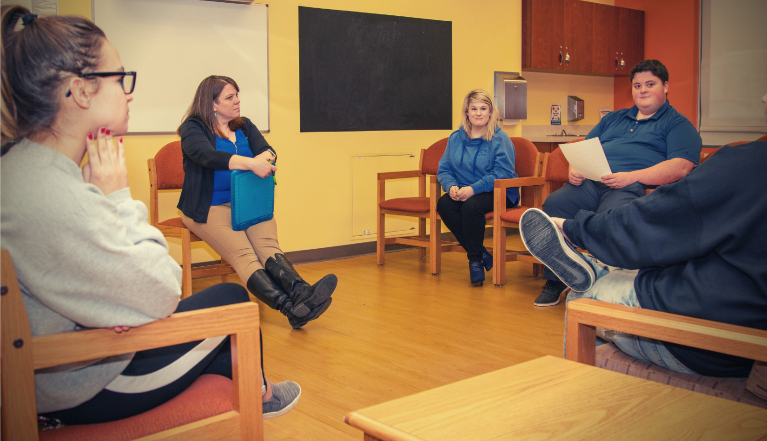
Treatment Philosophy
INPATIENT CARE AT SMOKEY POINT BEHAVIORAL HOSPITAL
Our treatment philosophy is based around a therapeutic milieu that fosters personal growth, integrity, and empathy. Group therapy is the core component of treatment and provides you the opportunity to interact with others at your own pace and comfort level and, in so doing, contributes to positive outcomes of working within a group experience in a caring, safe, and supportive environment—an essential factor in your recovery.

You will receive a copy of the group program schedule on your unit so you can plan to participate. Group meeting times and schedules are also posted on each unit.

Our goal is to help you reach your potential by strengthening your daily functioning and by accomplishing your short-term and long-term treatment goals, working with you, your family, and as a member of the therapeutic milieu. Change can be difficult and painful, but the result is growth and our staff will make every effort possible to support you and your family to make the necessary changes to lead a fulfilling life.

Respect and responsible behavior for all members of our therapeutic milieu is an important aspect of our treatment philosophy and we encourage you to share your feelings in an open and trusting atmosphere.

Change Process
You entered the Adult Inpatient program in order to grow and develop, which can evoke feelings of anger, sadness, loneliness and even fear. Our staff will support you, your family, and friends through the change process to ultimately have a positive experience.
Our goal is for you to develop coping skills that are necessary for your safety and to achieve success in addressing and completing your treatment goals. One of the objectives is to assist you to work with your feelings in a constructive and safe manner. Our staff will work with you to allow for healthy expression in a productive fashion. You will learn how to obtain the support that is both desired and necessary for personal growth—the goal during treatment is improvement in your ability to resolve problems and form healthy relationships with others.

Ultimately, we hold you, the patient, responsible for your own behaviors. You will be taught to connect the decision-making process, the behaviors and the final outcome. Our staff will ensure your safety, the safety of others on the unit and assist you to take responsibility for your own decision-making.
Assessments and Treatment
The Adult Inpatient Program addresses the biological, psychological, social, spiritual, and physical components of human behavior within the context of a brief hospitalization. You will be assessed by a comprehensive team of doctors, nurses, and therapists in order to determine the specific needs for your treatment. The problems identified in the assessments are used in the development of your individualized Master Treatment Plan.

Nursing Assessment:
A comprehensive nursing assessment is completed by a Registered Nurse within 8 hours.

Psychiatric Evaluation:
A psychiatrist/ARNP will complete within 24 hours.

History and Physical Assessment (H & P):
A physician or designee will complete within 24 hours.

Psychosocial Assessment:
A therapist will prepare a psychosocial evaluation within 72 hours of your admission.

Recreational Activity Assessment:
A Certified Recreational Therapists will complete within 72 hours.

Other Assessments:
Other assessments will be conducted as ordered, i.e., Chemical Dependency, Dietary, etc.

You will attend group sessions to help you better understand your illness and manage your symptoms, learn strategies and skills to assist in your recovery, and work on lifestyle and safety plans for maintaining your recovery and wellness. Your treatment will include medication evaluation and management, group and family therapy (case-by-case), education, intervention, and support.
Your nursing staff will be available to answer any questions during your treatment and is also responsible for providing you with medication. Throughout the day, you will have opportunities to meet other patients who may be dealing with similar issues and challenges. They can offer valuable wisdom, support, and insight and can help you in your recovery.

Treatment Planning
An individualized treatment plan will be developed utilizing the identified problems from within your completed assessments listed above, taking into consideration your bio-psycho-social, spiritual, and physical attributes, as well as your strengths and limitations.
You treatment plan addresses the specific goals and objectives which define appropriate interventions to be utilized and ultimately documents ongoing efforts to restore you to a higher level of functioning that would either permit discharge from the program or reflect the continued need for the intensity of inpatient hospitalization.

Treatment Team
Your treatment team includes clinicians responsible for your care during your stay at SPBH. They work together to provide excellent, compassionate, and effective care, and work with you to decide on the best treatment plan.
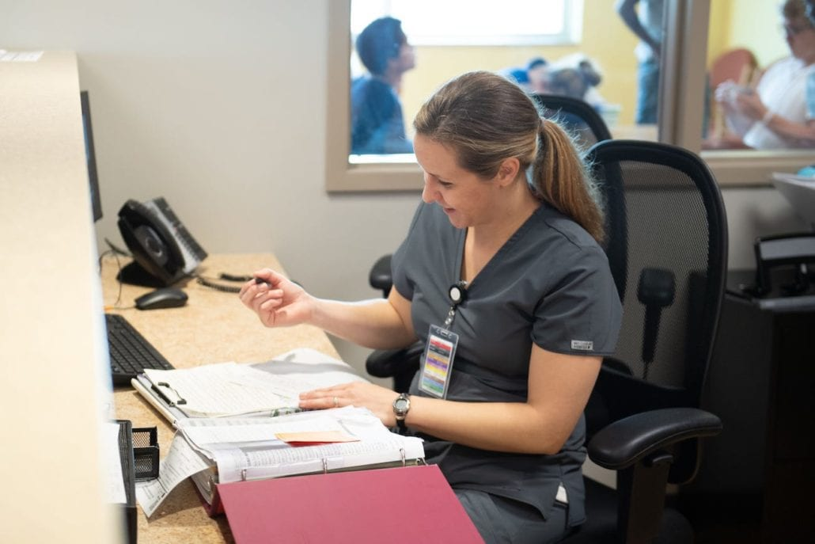
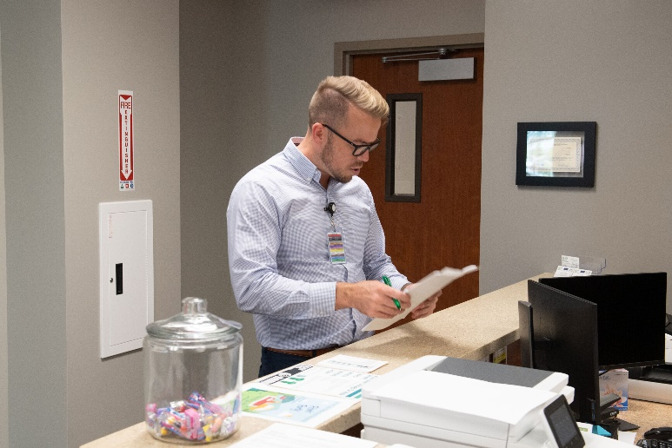

My Attending Psychiatrist is: Assigned on unit

My Program Therapist is: Assigned on unit

- Medical Staff: Psychiatrist, Advanced Registered Nurse Practitioner (ARNP), Primary Care Physicians (PCP).
- Program Therapist: Masters-level clinicians help coordinate your overall care (referred to as “case management”). They communicate with family and outside caregivers, lead family meetings, help with aftercare plans, and arrange for follow-up care. Your Program Therapist also helps you understand and manage your illness and provides support for your recovery.

- Nursing Staff: Registered Nurses (RN) and License Practical Nurses (LPN) may administer medications, provide support, and help coordinate your care, provide information to you and your family, and answer many of your questions. Each day and on each shift, a specific nurse is assigned to your care. Student nurses sometimes assist registered nurses in providing care.

- Recreational “Rec Therapist” Activity Therapist: Lead recreational activities, such as art therapy, music, and structured games. These groups help you learn skills, gain insights about yourself, and connect with other patients.

- Mental Health Technicians: MHT’s assist the nurses in monitoring your symptoms and functioning, taking vital signs, supervising meals, organizing activities, leading groups, and maintaining patient safety on the unit.

As with all health care, collaboration between you, your family, and your treatment team is crucial. We encourage you to learn as much as possible about your illness, including your symptoms, recovery, resilience, and wellness. Your treatment team needs to know about you—your strengths, your interests and abilities, the history of your illness, and your symptoms and behavior. While at SPBH, please ask questions and express concerns about your health and treatment. Learning about your illness will help you in your recovery.
You can identify staff members by the identification badges that they wear, displaying their name, photo, and department. All staff members must always wear Smokey Point Behavioral Hospital photo identification badges. If anyone without an identification badge approaches you, ask that he or she display his or her badge.
Structure of the Program

- Group Therapy – Group therapy is held each day with a focus on skill development and cognitive behavioral interventions to improve interpersonal, social, and occupational functioning. You will have the opportunity to meet with your therapist in a group-setting to address treatment issues in a supportive environment. Issues such as low self-esteem, stress management, relaxation, anger management, anxiety, depression, and mania are included in the focus of this group therapy.

- Psycho-educational/Skills Group – Psycho-educational/Skills Groups are held daily to provide patients with education on mental illness and to improve coping strategies to decrease symptoms.

- Individual Therapy – Your Program Therapist provides individual therapy on an as-needed-basis. Group therapy is the primary treatment model.

- Family Therapy – Family members may be requested to participate in family therapy with consent from you (the patient) and at the discretion of the treatment team.

- Addiction Education – You will explore the cause and effects of drugs and/or alcohol on physical, emotional, mental, and spiritual wellbeing if you have identified issues with chemical dependency.

- Activity Therapy – The Recreational Activity Therapy program helps you to structure leisure time while developing new skills. This program encourages the development of motor, cognitive, and social skills.

Program Rules and Guidelines
General Rules
- Be respectful of yourself and others.
- Patients are expected to talk to a staff person about the issues that led to admission.
- Patients need to follow staff directions.
- No physical contact between patients.
- There is a TV for general use and there are rules governing appropriate behavior in the dayroom and rules for deciding what is played on the television.
- Television will be turned off and other activities put away during scheduled groups to encourage active participation in the treatment program.
- Patients are responsible for making their own beds and keeping their rooms neat.
- Room checks are done daily by staff to make sure rooms are safe;
  - If prohibited items are found they will removed.
- Room doors are locked during programming, but are open during free.
- Furniture and mattresses are not to be moved due to hospital safety regulations.

Confidentiality
Privacy and confidentiality of all patients and their families is respected and protected. Personal Health Information (PHI) is available only to the staff directly responsible for your care in order to provide treatment. Efforts are strictly enforced to keep confidentiality and to maintain privacy within the treatment setting.
For privacy and the privacy of others, names of clients should never be shared outside of the program. Please do not discuss information about other clients. Do not share information: address, email, phone number, etc. with other clients. For confidentiality and protection this is strictly prohibited.

Patient Identification Number aka “ACCESS CODE”
While you are a patient at SPBH, confidentiality and privacy are carefully protected by the entire SPBH staff in accordance with state and federal laws.
To assist in preserving confidentiality, each patient is assigned an identification number upon admission.
This will be your access code while receiving treatment—your friends and family will not be able to contact you without being able to provide your access code.

My ACCESS CODE # is

Telephone Calls
Be sure to share your access code with friends and family that you want to receive phone calls from while at SPBH. If your family or friends try to contact you and cannot provide your 4-digit code, SPBH cannot confirm or deny that you are a patient here.
Phone calls may be limited in duration, due to all patients needing phone time.
Mail
Incoming mail is given out daily. Letters and packages must be opened in front of staff to prevent the possibility of dangerous or restricted items getting into patients’ possession.
Meals and Snacks
Each Inpatient Program have allotted mealtimes for breakfast, lunch, and dinner and are served in the dining room, unless a written order indicates you must have your meal on the unit. Snacks are also available on each unit. SPBH’s Dietary Services accommodate diets for patients with medical restrictions (e.g., diets appropriate for patients with diabetes or food allergies). Dietary Services can also provide meals for vegetarians and vegans and meals based on religious principles (e.g. kosher). This will be identified during your intake assessment. We do not provide caffeinated beverages during your inpatient stay as these may affect your metabolism. Food is not allowed in patients rooms.
Outside Food
For safety, sanitation, and dietary management purposes, visitors may NOT bring you outside food or beverages. Additionally, certain foods pose a risk to your health if you are taking a class of medications known as MAO inhibitors. Your physician and nurse will instruct you about food or beverage restrictions related to your medication. Ask your nurse if you have questions or concerns about what you should or should not be eating and drinking. Meals and snacks are provided by the hospital.
Secure Units
All inpatient units are locked and all patients are seen by staff at regular intervals to promote a safe environment. Some inpatient units allow patients to leave the unit with family or friends while supervised. Please check with your treatment team.
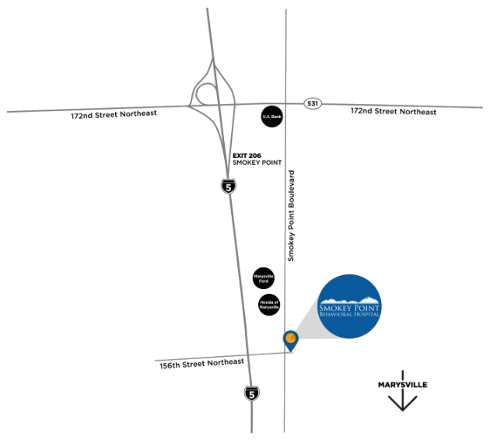
Mailing Address
Smokey Point Behavioral Hospital
3955 156th St. NE,
Marysville, WA 98271

Phone #:
(Toll-free) 844-202-5555
(Local) 360-651-6400

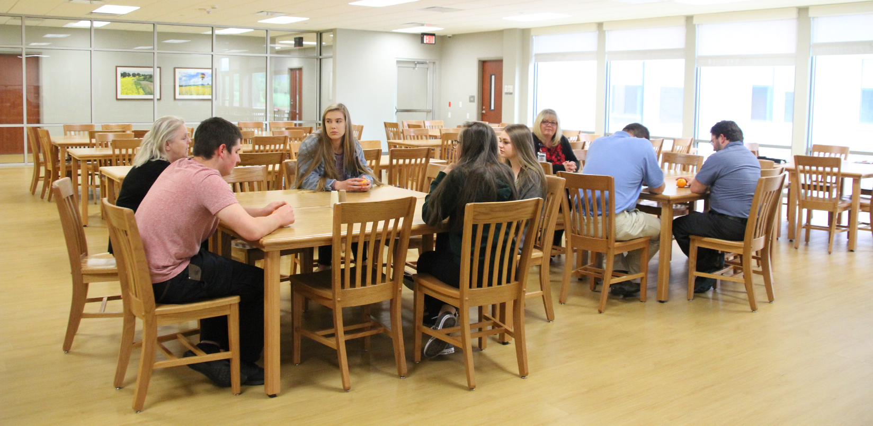
Visitation
Visitation is held seven days a week and is intended for you and your family/friends to work together on treatment goals. Visitation times are included in the schedule and posted on the units. Visitation is limited to two visitors at a time. Sometimes visitors can only come to the hospital during a certain time because of work, family, or other obligations.
Family, friends, and guardians wishing to visit outside of visiting hours should call their assigned program therapist about special arrangements for visiting. You also have the right to refuse visitors. Visitors may also bring items that you might want or need during your stay but will first be taken by staff to complete a thorough search and inventory of the items.

Adolescent Visitation Times
6:30 pm – 7:30 pm

Adult Visitation Times
7:30 pm – 8:30 pm
Minors under age 18 may not visit during regular visiting hours. Visitation with minors should be scheduled with your program therapist.
Children are not to be left unsupervised in the main lobby.
Physical Care
Physical care includes medical evaluation, treatment or possible consultation of physical problems and complications. The medical and nursing staff work together to observe, evaluate, and treat the physical, medical, and your nursing needs. Medications are determined and specifically ordered by your attending psychiatrist/provider in accordance with your diagnosis, evaluation and treatment plan.
Worship
You are permitted to exercise your religious beliefs and staff will assist you in facilitating practice of those beliefs. Patients are helped to explore spirituality in a non-threatening manner.
Property Damage
While the hospital recognizes that many of the patients admitted to SPBH have trouble in managing their anger, deliberate destruction of hospital property will not be accepted. In instances where this occurs, the cost for repairs will be billed to you (the patient).
Special Precautions
Special precautions must be taken with patients who are at risk for self-injury, assault, running away or setting fires. We have a deep commitment to the safety of all our staff and others. If a patient is believed to be in danger of harming themselves or someone else, the use of physical restraint or seclusion may be necessary. This is always used as a last alternative. These precautions require clinical justification and are employed only to protect the patient from self-injury or from injuring others. Orders for restraint or seclusion must be given by the attending or on-call provider while working in conjunction with nursing staff.

Restrictions
Patients are expected to assume responsibility for their own behavior while at SPBH. Certain rules and guidelines must be adhered to by patients in order to maintain a safe and therapeutic milieu. When patients break rules or conduct themselves in a manner that is destructive to the program, specific consequences for that behavior are immediately administered. Staff members recognize that restrictions and consequences must be given, considering the capabilities and limitations of each patient.
A definition of restrictions and consequences are as follows:
- Time Out – time out is the removal of the patient from the milieu to a designated area for a specific amount of time to collect their own thoughts and to reflect on inappropriate behavior.

- Close Observation – when a patient needs additional support and monitoring, they may be placed on close observation.

- Unit Restriction – if communication and cooperation between the patient and other patients or the staff breaks down, patients may be restricted to their unit. Activities and meals take place within the unit during this restriction. Visitation may be limited or unavailable during this unit restriction, but family therapy sessions are not affected by unit restriction.

- Room Restriction – patients may be restricted to or from their room when they cannot be trusted to control dangerous and destructive behaviors.

- Association Restriction – if patients are having relationships with other patients that may be detrimental to their treatment goals, they may be prohibited from interacting.

- Dayroom closure – staff may temporarily close the common areas on the unit to help regain a therapeutic environment if individuals engage in disruptive behaviors.

Discharge Planning
Discharge planning begins upon admission and is an integral part of the treatment process and is documented throughout treatment.

During treatment plan review sessions, the discharge plan is assessed and revised by the entire treatment team and you are encouraged to participate in this process. The physician and/or treatment team advises the patient of the criteria for discharge and modifications that might occur.

Under the direction of the attending psychiatrist, the treatment team coordinates discharge planning. The goal of discharge planning is to ensure continuity of care which best meets your needs and facilitates a successful return to the community. Discharge planning activities include linkage with community resources, supports, and providers in order to promote a patient’s return to a higher level of functioning in the least restrictive environment.

Discharge planning provides you a process for addressing your need for continuing care, treatment, and services after discharge. The discharge plan describes the reason for and conditions under which you are discharged. The discharge plan also describes the shifting of responsibility of care following discharge and it is

essential that the discharge aftercare plan be completed sufficiently prior to discharge to allow for you to be connected to appropriate clinicians, programs, or services.

The criteria for discharge will vary from patient to patient according to each patient’s specific circumstances and needs. For a patient to be discharged from the Adult Inpatient Program the following criteria must be met:

- The goals of the treatment will have been substantially met at this level of care (unless transfer to another treatment facility is indicated) and a discharge plan is in place that meets any continuing needs
- Follow-up goals and treatment plans for a lesser level of care have been established
- Releasing or transferring the patient to a less intensive level of care does not pose a threat to themselves, others, or property

Any discharge from the hospital requires the written order of a physician. The order should specify the day of the discharge, the condition of the patient at discharge, and the discharge diagnosis. Aftercare services are defined in the discharge plan.

Discharges are generally scheduled Monday-Friday before 12pm to ensure a smooth transition including reliable transportation, access to medications you may have stored in our pharmacy, access to outpatient support resources and your pharmacy to get prescriptions filled. We will work with you to coordinate your day of discharge plan.

Discharge Against Medical Advice (AMA)
Discharges Against Medical Advice may occur under the following conditions:
- The Patient / Legal guardian(s) enters a written request for discharge.
- The Patient / Legal guardian(s), after being counseled by the attending physician, continues to demand a discharge.
- The Patient is assessed and is no longer a danger to themselves, others or property. If the patient does represent a danger to self or others, the attending physician will seek court-ordered detention of the patient for the safety of the patient or others.

NOTES

